CrowSoft WebApp Copy and Publish to Dev Server

Contents

The web application service 2

Service Configuration 2

How to Check the Service Status 2

How to stop the service 2

How to start the service 2

Check if the web application is working 3

Copy Web App Project Files to Dev Server 3

To publish the Web Application 4

## The web application service

A service is required to be able to run the application without having to manually start the application in the console.

### Service Configuration

The service name is: **crowsoft-webapp.service**

The config file of the service: located at /etc/system/system/crowsoft-webapp.service

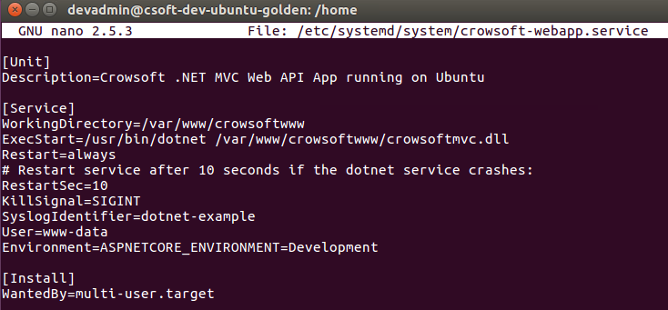

### How to Check the Service Status

To check the status of the service: *sudo systemctl status crowsoft-webapp.service*   
NB: Make sure the status are: **active (running)**

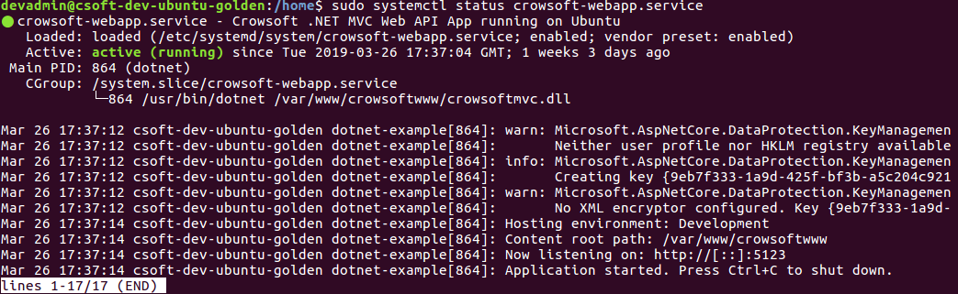

### How to stop the service

To stop the service: *sudo systemctl stop crowsoft-webapp.service*



### How to start the service

To start the service: *sudo systemctl start crowsoft-webapp.service*



### Check if the web application is working

After the service is running, test the web app, open FireFox, and go enter localhost

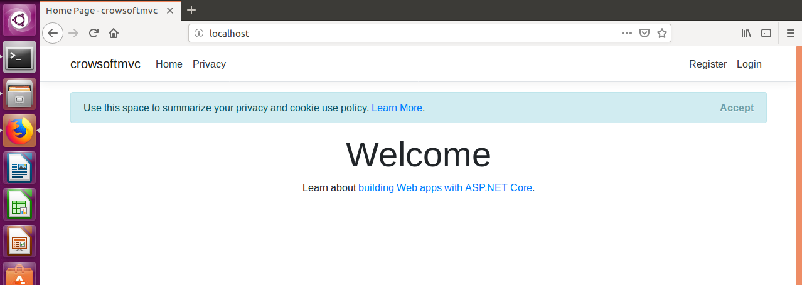

## Copy Web App Project Files to Dev Server

On the Dev Server, the folder for the project files should copy into the following folder:

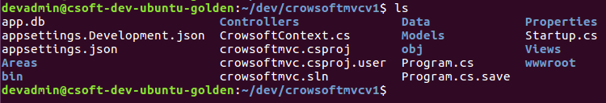

**NOTE: The Staging and Production server will not have this folder. We should publish from either Jenkins or Artifactory for the final build.**

## To publish the Web Application

Steps to publish new code:

1. Make sure the service is stopped. Command to stop: ***sudo systemctl stop crowsoft-webapp.service***
2. Run the following command Command: ***sudo dotnet publish ~/dev/crowsoftmvcv1/crowsoftmvc.csproj –c release –o /var/www/crowsoftwww***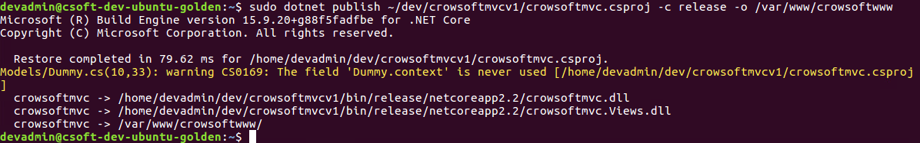
3. Now start the service. Command to start: ***sudo systemctl start crowsoft-webapp.service***
4. Optional: Check status of service: ***sudo systemctl status crowsoft-webapp.service***
5. This is how the folder content should look like. 